Curvilinear Dissection

Definition
# Source: AI Source: Provided by: [Data Path: Persons Table -> ID Column: 1, Name_En Column: Motasem Essam] -> From: [ChatGPT] on [7/25/2026]
Curvilinear Dissection is a geometric dissection method in which a figure is divided into two or more regions using one or more curved dividing lines. These curves may be circular arcs, elliptical arcs, parabolic curves, sinusoidal curves, or other smooth or piecewise-curved lines.
The resulting pieces may have curved boundaries, straight boundaries, or a combination of both.
Simple definition: Curvilinear dissection is dividing a geometric figure into smaller pieces using curved lines.
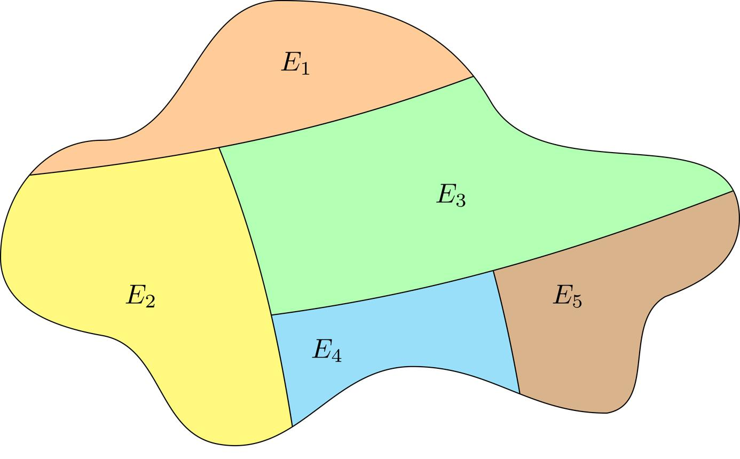
asignatura.us.es
Important distinction: Curvilinear dissection is a descriptive classification rather than a universally standardized category. It focuses on the use of curved boundaries in the division. Unlike circular dissection, it does not require the original figure or all the dividing curves to be circular.

Main Classification
# Source: AI Source: Provided by: [Data Path: Persons Table -> ID Column: 1, Name_En Column: Motasem Essam] -> From: [ChatGPT] on [7/25/2026]
The following is a practical classification. The categories may overlap: for example, a dissection can use both circular arcs and straight cuts, or it can create equal-area pieces using curved boundaries.

1. Circular-Arc-Based Dissection
# Source: AI Source: Provided by: [Data Path: Persons Table -> ID Column: 1, Name_En Column: Motasem Essam] -> From: [ChatGPT] on [7/25/2026]
Uses circular arcs as dividing boundaries. The arcs may come from the same circle or from different circles.
Example: Dividing a circular region into smaller curved regions using intersecting arcs.
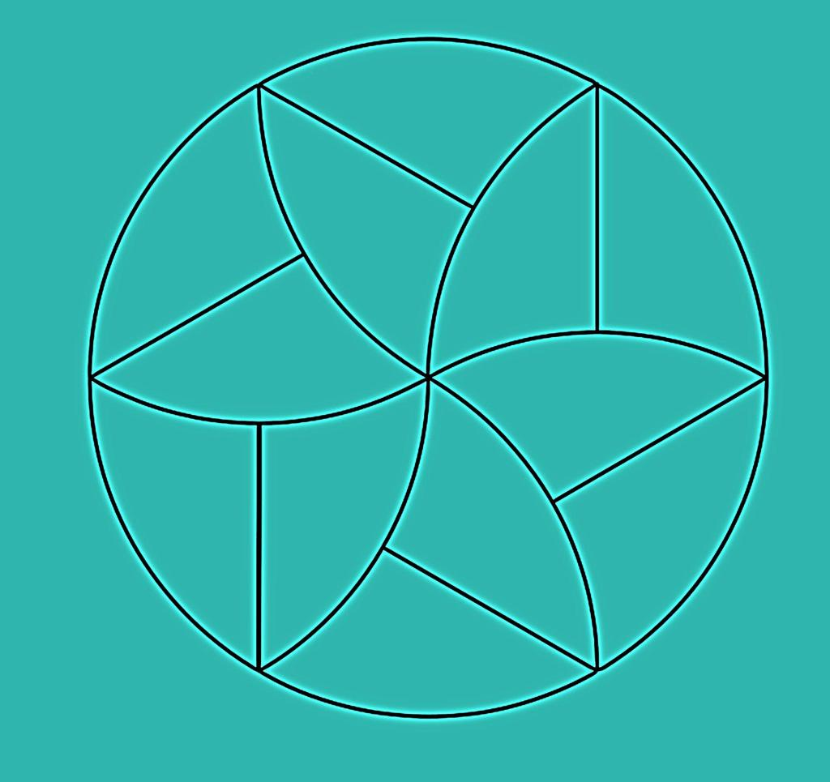
Detailed Mathematical Examples
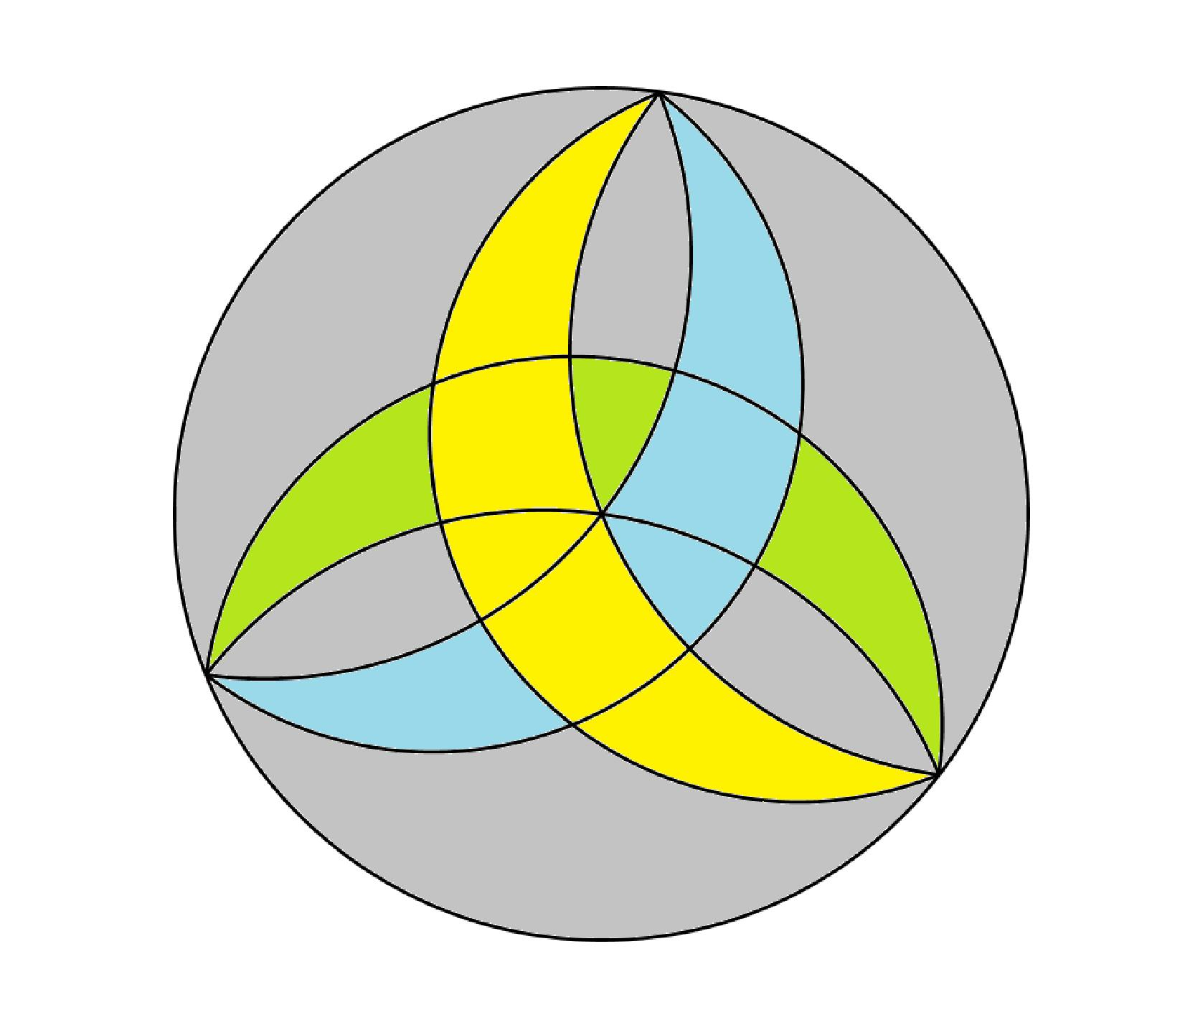
Suppose a circular region of radius $r=6$ is divided into four equal sectors using two perpendicular diameters.
The total area is
$$A=πr^{2}=36π$$
Each sector has area
$$A_{\text{sector}}=\frac{36π}{4}=9π$$
Although the radial boundaries are straight, the pieces have circular-arc boundaries. This is also a circular dissection.

2. Concentric-Curve Dissection
# Source: AI Source: Provided by: [Data Path: Persons Table -> ID Column: 1, Name_En Column: Motasem Essam] -> From: [ChatGPT] on [7/25/2026]
Uses curves sharing a common center, commonly concentric circles, to create rings or curved bands.
Example: Dividing a disk into a central circle and two surrounding annular regions.
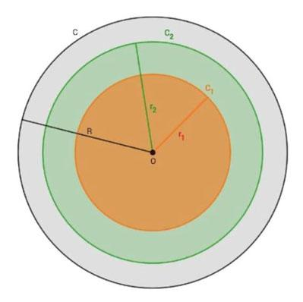
Detailed Mathematical Examples
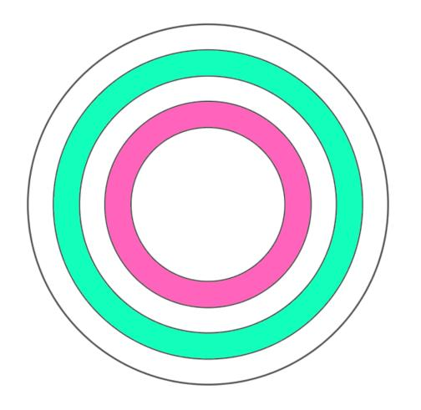
Consider three concentric circles with radii $2$, $4$, and $6$.
The central disk has area
$$A_{1}=π{\left(2\right)}^{2}=4π$$
The middle annular region has area
$$A_{2}=π\left(4^{2}-2^{2}\right)=12π$$
The outer annular region has area
$$A_{3}=π\left(6^{2}-4^{2}\right)=20π$$
Therefore,
$$A_{\text{total}}=4π+12π+20π=36π$$
This agrees with the area of the largest disk, $π{\left(6\right)}^{2}=36π$.

3. Sector-Based Curvilinear Dissection
# Source: AI Source: Provided by: [Data Path: Persons Table -> ID Column: 1, Name_En Column: Motasem Essam] -> From: [ChatGPT] on [7/25/2026]
Creates fan-shaped pieces bounded partly by curved arcs and partly by straight segments or rays.
Example: Dividing a circular region into sectors of different central angles.
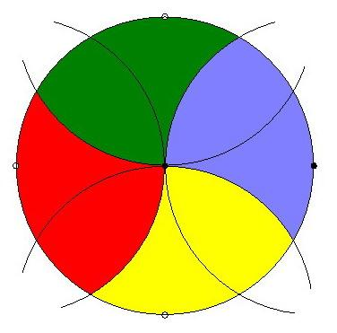
Detailed Mathematical Examples
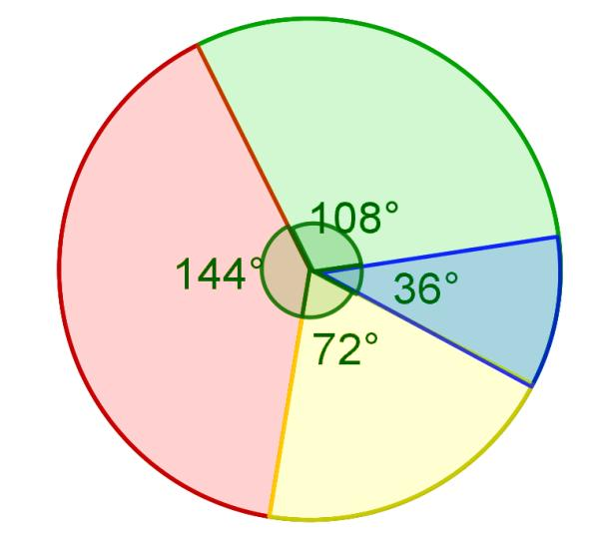
For a circular sector with radius $r$ and central angle $θ$ measured in degrees,
$$A=\frac{θ}{{360}^{∘}}πr^{2}$$
For a circle of radius $6$, divide it into sectors of ${60}^{∘}$, ${120}^{∘}$, and ${180}^{∘}$.
Their areas are
$$A_{1}=6π, A_{2}=12π, A_{3}=18π$$
Their sum is $36π$, the area of the original disk.

4. Elliptical-Curve Dissection
# Source: AI Source: Provided by: [Data Path: Persons Table -> ID Column: 1, Name_En Column: Motasem Essam] -> From: [ChatGPT] on [7/25/2026]
Uses elliptical arcs as dividing boundaries, producing pieces with curved edges that are not necessarily circular.
Example: Dividing a region using portions of two ellipses.
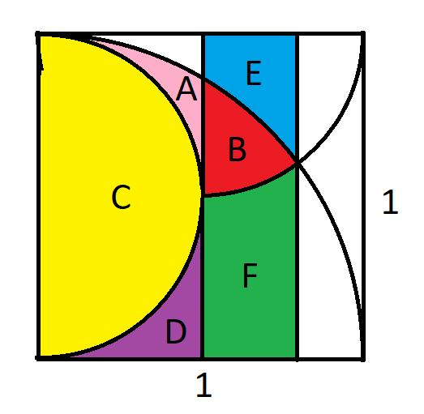
Detailed Mathematical Examples
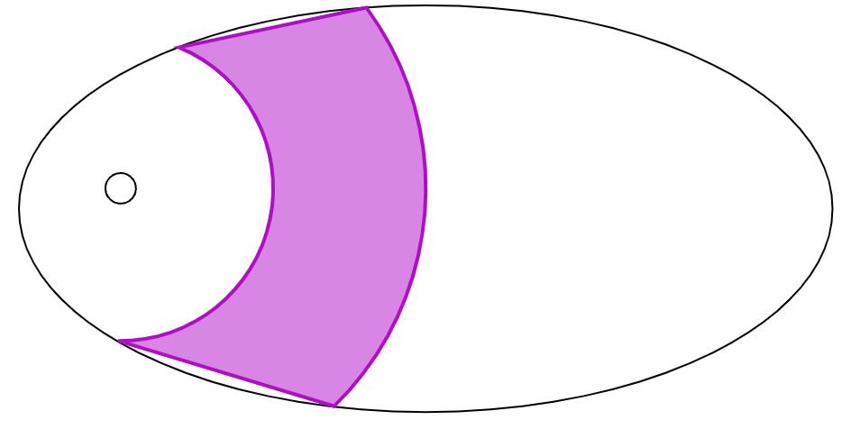
An ellipse with semimajor axis $a$ and semiminor axis $b$ has area
$$A=πab$$
For $a=5$ and $b=3$,
$$A=15π$$
If a valid curved cut divides this ellipse into two regions with areas $A_{1}$ and $A_{2}$, then
$$A_{1}+A_{2}=15π$$
The exact areas depend on the location and equation of the dividing curve. They cannot be determined from the ellipse's dimensions alone.

5. Parabolic-Curve Dissection
# Source: AI Source: Provided by: [Data Path: Persons Table -> ID Column: 1, Name_En Column: Motasem Essam] -> From: [ChatGPT] on [7/25/2026]
Uses parabolas or parabolic arcs to divide a figure into regions.
Example: Using a parabolic arc to separate a curved segment from a rectangular or polygonal region.
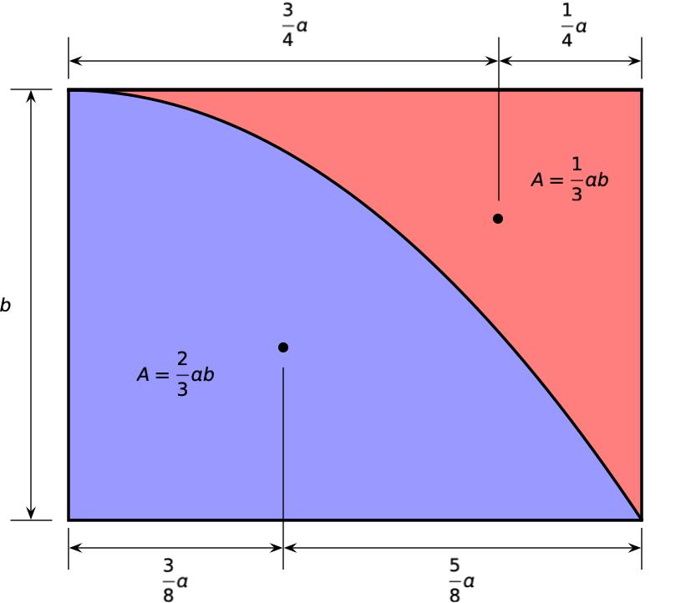
Detailed Mathematical Examples
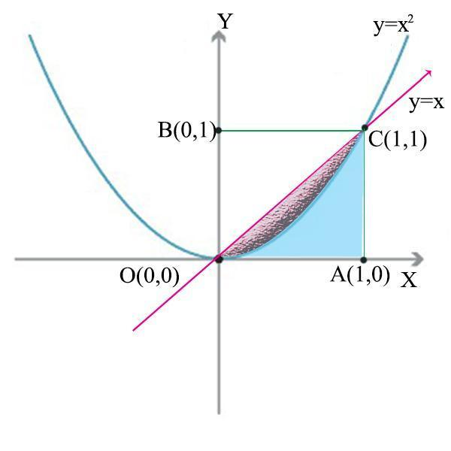
Consider the parabola
$$y=x^{2}$$
inside the rectangle $-2≤x≤2$, $0≤y≤4$.
The rectangle has area
$$A_{\text{rectangle}}=4×4=16$$
The area below the parabola and above the $x$-axis is
$$A_{1}=\int_{-2}^{2}{x^{2}} dx=\frac{16}{3}$$
The remaining area inside the rectangle is
$$A_{2}=16-\frac{16}{3}=\frac{32}{3}$$
Thus, the curved boundary divides the rectangle into two regions whose areas sum to $16$.

6. Wavy-Curve Dissection
# Source: AI Source: Provided by: [Data Path: Persons Table -> ID Column: 1, Name_En Column: Motasem Essam] -> From: [ChatGPT] on [7/25/2026]
Uses wave-like or oscillating curves to form pieces with undulating boundaries.
Example: Dividing a rectangle into alternating wavy strips.
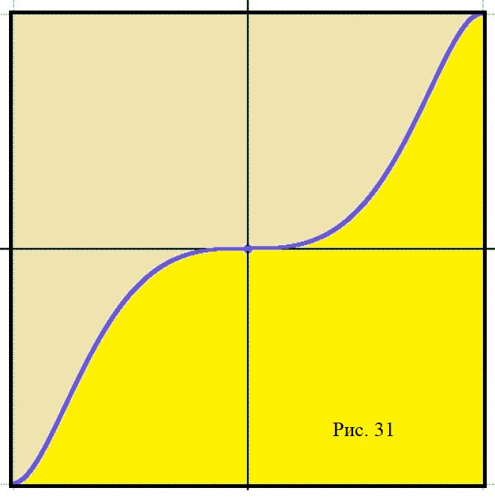
Detailed Mathematical Examples
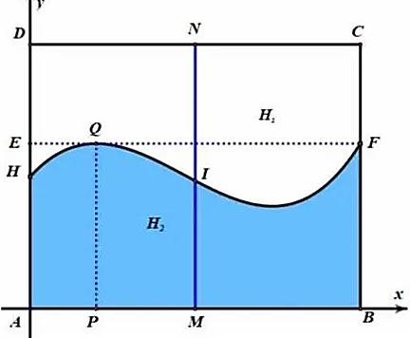
A wavy dividing curve can be modeled by a sinusoidal function, such as
$$y=2+\sin{x}$$
The curve's shape depends on its amplitude, frequency, and vertical shift.
For example, consider the rectangle $0≤x≤2π$, $0≤y≤3$. The area below the curve is
$$A_{1}=\int_{0}^{2π}{\left(2+\sin{x}\right)} dx=4π$$
The rectangle's total area is $6π$, so the area above the curve is
$$A_{2}=6π-4π=2π$$
This example illustrates how calculus can calculate the areas of regions bounded by curved lines.

7. Freeform-Curve Dissection
# Source: AI Source: Provided by: [Data Path: Persons Table -> ID Column: 1, Name_En Column: Motasem Essam] -> From: [ChatGPT] on [7/25/2026]
Uses curved lines that do not need to follow a standard curve such as a circle, ellipse, or parabola.
Example: Dividing an irregular region with two custom smooth curves.
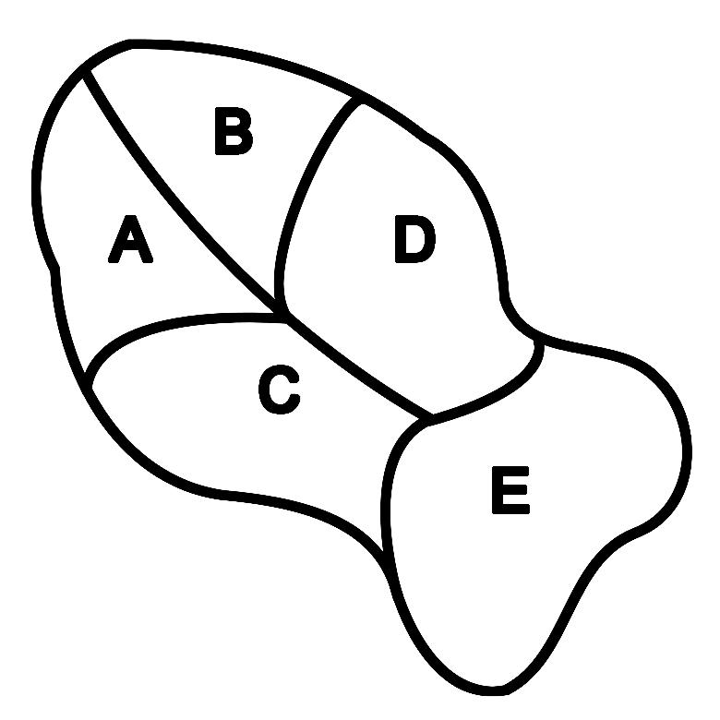
Detailed Mathematical Examples
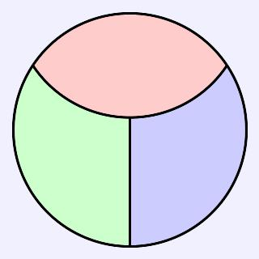
A freeform curve does not have to be a standard conic or circular arc. It may be described by a parametric equation, a spline, or another curve representation.
For example, a smooth curve may be represented parametrically as
$$x=x\left(t\right), y=y\left(t\right)$$
For a region between curves $y=f\left(x\right)$ and $y=g\left(x\right)$, where $f\left(x\right)≥g\left(x\right)$ on $\left[a,b\right]$, the area is
$$A=\int_{a}^{b}{\left(f\left(x\right)-g\left(x\right)\right)} dx$$
The specific area depends on the actual curves and their intersection points.

8. Mixed Straight-and-Curved Dissection
# Source: AI Source: Provided by: [Data Path: Persons Table -> ID Column: 1, Name_En Column: Motasem Essam] -> From: [ChatGPT] on [7/25/2026]
Combines straight cuts and curved cuts in the same dissection.
Example: A rectangle divided by a diagonal segment and a circular arc.
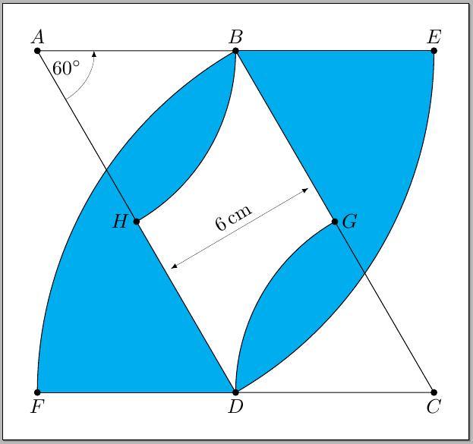
Detailed Mathematical Examples
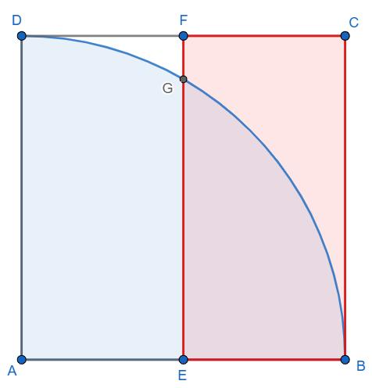
Consider a $6×4$ rectangle with a semicircle of radius $2$ attached externally along one of its shorter sides. The combined area is
$$A=6\left(4\right)+\frac{1}{2}π{\left(2\right)}^{2}$$
Therefore,
$$A=24+2π≈30.28$$
A further straight or curved cut can divide the combined figure into additional regions. The area formula above assumes the rectangle and semicircle have no overlapping interiors.

9. Equal-Area Curvilinear Dissection
# Source: AI Source: Provided by: [Data Path: Persons Table -> ID Column: 1, Name_En Column: Motasem Essam] -> From: [ChatGPT] on [7/25/2026]
Divides a figure into pieces with equal areas, using curved boundaries where needed.
Example: Dividing a circular region into four equal-area sectors.
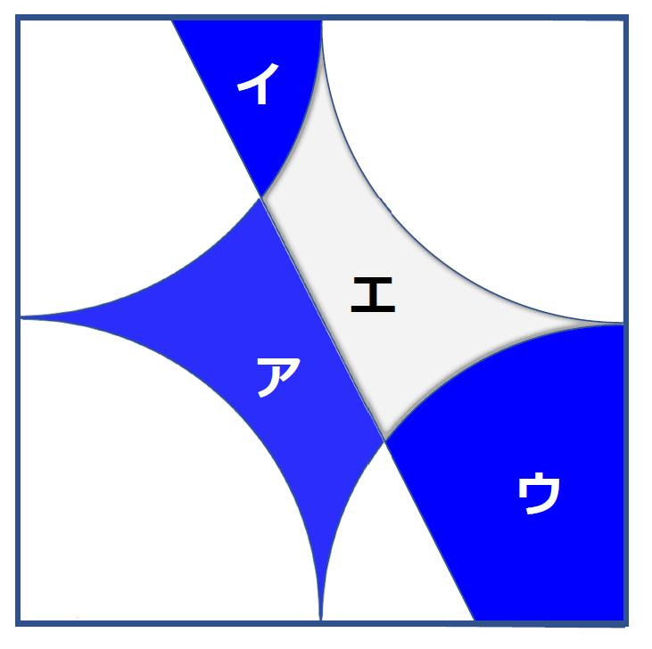
Detailed Mathematical Examples
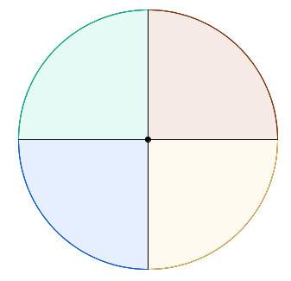
A disk of radius $4$ has area
$$A=16π$$
Dividing it into four equal quadrants gives
$$A_{\text{each}}=\frac{16π}{4}=4π$$
Equal-area curvilinear dissection does not require every piece to have the same shape. It requires only that the areas be equal.

10. Rearrangement-Based Curvilinear Dissection
# Source: AI Source: Provided by: [Data Path: Persons Table -> ID Column: 1, Name_En Column: Motasem Essam] -> From: [ChatGPT] on [7/25/2026]
Creates curved pieces that can be moved and reassembled into another arrangement without changing the pieces themselves.
Example: Rearranging curved pieces from a circular or irregular region to form a different outline.
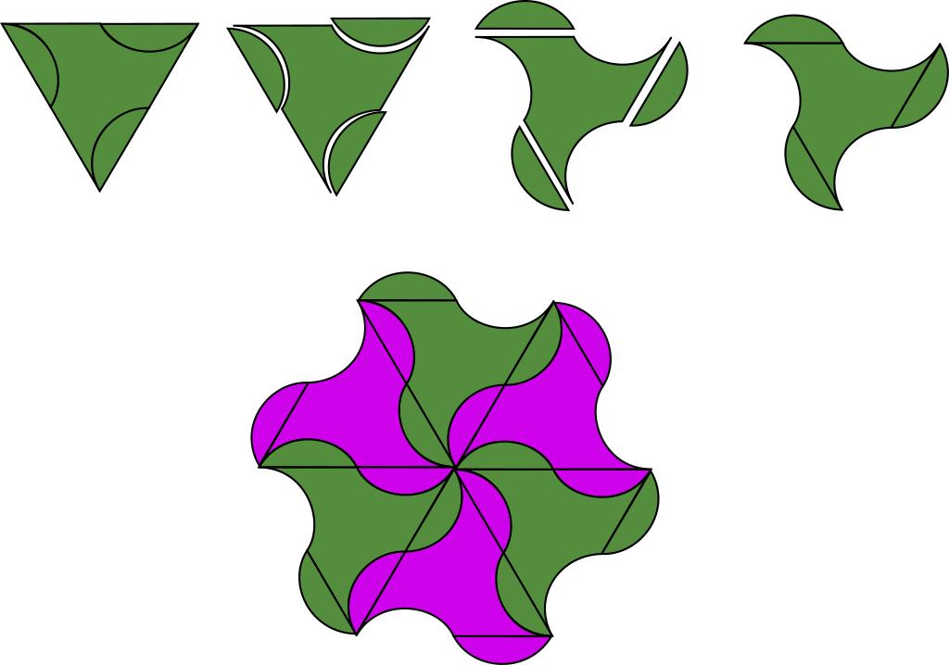
Detailed Mathematical Examples
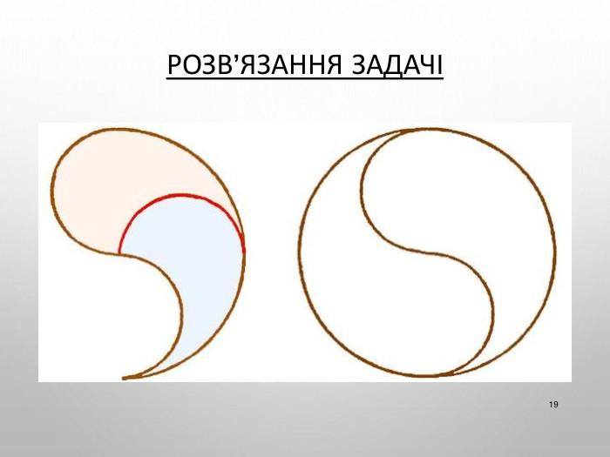
Suppose a figure of area $A$ is divided into curved pieces and rearranged without stretching, cutting further, or overlapping their interiors.
Then
$$A_{\text{original}}=A_{\text{rearranged}}$$
This method is useful in geometric puzzles and area-equivalence problems. However, an equal-area result does not by itself prove that the proposed pieces can actually be rearranged into the desired shape; the boundaries and fit must also be verified.

11. Multi-Stage Curvilinear Dissection
# Source: AI Source: Provided by: [Data Path: Persons Table -> ID Column: 1, Name_En Column: Motasem Essam] -> From: [ChatGPT] on [7/25/2026]
Divides a figure using curved boundaries in successive stages, creating progressively smaller regions.
Example: First dividing a disk with a circular arc, then subdividing one resulting region with another curve.
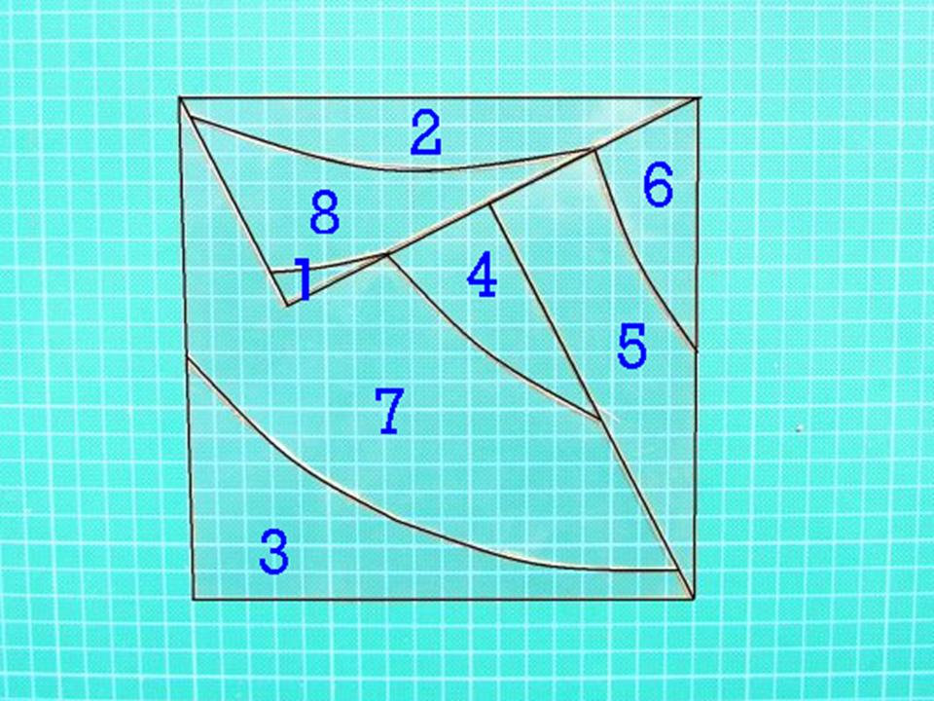
Detailed Mathematical Examples
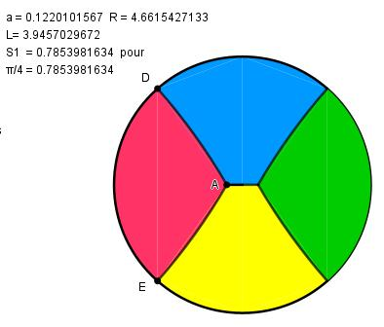
Suppose a disk of radius $5$ is divided into two regions with areas $A_{1}$ and $A_{2}$. One region is then divided into two smaller regions, $A_{11}$ and $A_{12}$.
The area relationships are
$$A_{1}=A_{11}+A_{12}$$
and
$$A_{\text{total}}=A_{11}+A_{12}+A_{2}=25π$$
The same area-preservation principle applies regardless of how many successive stages are used.

Key Formulas for Curvilinear Dissection
# Source: AI Source: Provided by: [Data Path: Persons Table -> ID Column: 1, Name_En Column: Motasem Essam] -> From: [ChatGPT] on [7/25/2026]
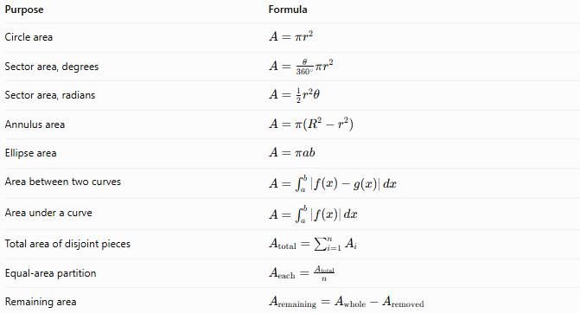
Purpose | Formula
Circle area | $$A=πr^{2}$$
Sector area, degrees | $$A=\frac{θ}{{360}^{∘}}πr^{2}$$
Sector area, radians | $$A={\frac{1}{2}r}^{2}θ$$
Annulus area | $$A=π\left(R^{2}-r^{2}\right)$$
Ellipse area | $$A=πab$$
Area between two curves | $$A=\int_{a}^{b}{\left|f\left(x\right)-g\left(x\right)\right|} dx$$
Area under a curve | $$A=\int_{a}^{b}{\left|f\left(x\right)\right|} dx$$
Total area of disjoint pieces | $$A_{\text{total}}=\sum_{i=1}^{n}{A_{i}}$$
Equal-area partition | $$A_{\text{each}}=\frac{A_{\text{total}}}{n}$$
Remaining area | $$A_{\text{remaining}}=A_{\text{whole}}-A_{\text{removed}}$$
For curved regions, the appropriate formula depends on the curve equations and the boundaries of the region. Calculus is often useful when the pieces cannot be described using elementary area formulas.

Comparison with Other Dissection Types
# Source: AI Source: Provided by: [Data Path: Persons Table -> ID Column: 1, Name_En Column: Motasem Essam] -> From: [ChatGPT] on [7/25/2026]
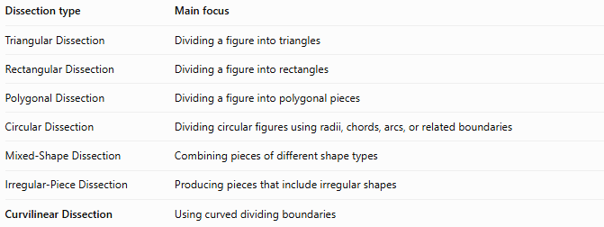
Dissection type | Main focus
Triangular Dissection | Dividing a figure into triangles
Rectangular Dissection | Dividing a figure into rectangles
Polygonal Dissection | Dividing a figure into polygonal pieces
Circular Dissection | Dividing circular figures using radii, chords, arcs, or related boundaries
Mixed-Shape Dissection | Combining pieces of different shape types
Irregular-Piece Dissection | Producing pieces that include irregular shapes
Curvilinear Dissection | Using curved dividing boundaries
Curvilinear dissection overlaps with circular dissection, but they are not identical. A circular dissection specifically concerns circular geometry, whereas curvilinear dissection can use many types of curves and can begin with a polygon, rectangle, or irregular region.

Classification Summary
# Source: AI Source: Provided by: [Data Path: Persons Table -> ID Column: 1, Name_En Column: Motasem Essam] -> From: [ChatGPT] on [7/25/2026]
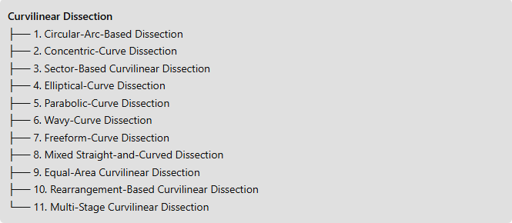
Curvilinear Dissection
├── 1. Circular-Arc-Based Dissection
├── 2. Concentric-Curve Dissection
├── 3. Sector-Based Curvilinear Dissection
├── 4. Elliptical-Curve Dissection
├── 5. Parabolic-Curve Dissection
├── 6. Wavy-Curve Dissection
├── 7. Freeform-Curve Dissection
├── 8. Mixed Straight-and-Curved Dissection
├── 9. Equal-Area Curvilinear Dissection
├── 10. Rearrangement-Based Curvilinear Dissection
└── 11. Multi-Stage Curvilinear Dissection

Key Points
# Source: AI Source: Provided by: [Data Path: Persons Table -> ID Column: 1, Name_En Column: Motasem Essam] -> From: [ChatGPT] on [7/25/2026]
- Curvilinear dissection uses one or more curved dividing boundaries.
- Curves may be circular, elliptical, parabolic, wavy, or freeform.
- A piece can have both straight and curved edges.
- Pieces may have equal or unequal areas.
- The pieces must cover the original figure without gaps or overlapping interiors.
- Curved regions can be measured using geometric formulas, integration, or suitable numerical methods.
- The listed categories are descriptive and may overlap.

Conclusion
# Source: AI Source: Provided by: [Data Path: Persons Table -> ID Column: 1, Name_En Column: Motasem Essam] -> From: [ChatGPT] on [7/25/2026]
Curvilinear Dissection is the division of a geometric figure using curved boundaries to create smaller regions. It extends ordinary polygonal dissection to figures involving arcs and more general curves, making it useful for area calculations, geometric rearrangements, curved-region analysis, and mathematical modeling.

